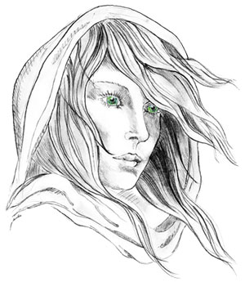
THE WHITE LADY
WORSTEAD
The Freehouse in the heart of Worstead
Pub, Restaurant, Luxury Bed & Breakfast and
Self-Catering Cottages

Lunch Menu

Light Bites
Peppered Semolina Calamari w/ Romesco £6
Ox Cheek & Bone Marrow Croquette w/ a Bourbon Glaze £6
Tempura Prawns £6

Sandwich’s
Cheddar Cheese & Pickle £9
Roast Ham & Wholegrain Mustard Mayonnaise £9
Fish Finger & Chunky Tar Tar £9
Chicken & Bacon Club £9

All Sandwiches served on White boomer & with Skin on fries.

Bites
Ploughman’s Board £10
Ham, Egg & Chips £10

All of our meat is locally sourced (Swannington farm to fork)
Vegetables are seasonal and local (when available)

Management advises that food prepared here may contain or have come in contact with peanuts, tree nuts, soybeans, milk, eggs, wheat, shellfish or fish. Please ask a member of staff about the ingredients in your meal before placing your order. Thank you.

