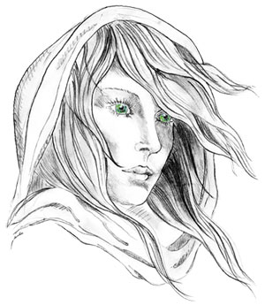
THE WHITE LADY
WORSTEAD
The Free house in the heart of Worstead -
Pub, Luxury Bed & Breakfast and Restaurant

BREAKFAST MENU
Please complete and return to the bar before 8.00pm on the night of stay. Thank you.
DATE:
TIME (Between 07.30am & 9.00am):
SURNAME:
ROOM NAME or COTTAGE NUMBER:
NUMBER OF GUESTS:

ITEM | GUEST 1 | GUEST 2 | GUEST 3 | GUEST 4
Orange Juice
Pineapple Juice
Apple Juice
Cranberry Juice
Water
Tea
Coffee
Toast - White
Toast - Brown
Toast - Mixed
Jam
Marmalade
Weetabix
Cornflakes
Branflakes
Coco Pops
Whole Milk
Semi Skimmed
Soya Milk

Full English
Sausages (2)
Vegetarian Sausages (2)
Bacon (2)
Grilled Tomato
Mushrooms
Beans
Hash Brown (2)
Black Pudding
Eggs – please select one option from a choice of:
Fried (2)
Poached (2)
Scrambled

** Please note if you select ‘Full English’ it will include 2 sausages, 2 bacon, beans, grilled tomato, mushrooms, hash brown, & black pudding – please tick egg choice.

