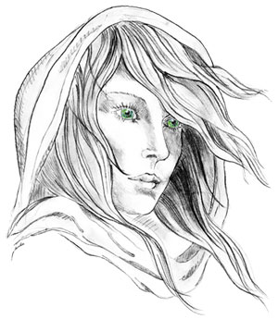
THE WHITE LADY
WORSTEAD
The Free house in the heart of Worstead
Pub, Restaurant Luxury Bed & Breakfast and
Self-Catering Cottages

Children’s Menu

Beans on toast £4

Fish and chips served with garden peas £6

Sausage and mash – british pork shoulder sausages served on a bed of creamy mashed potato with caramelised red onion and rosemary gravy £6

Management advises that food prepared here may contain or have come in contact with peanuts, tree nuts, soybeans, milk, eggs, wheat, shellfish or fish. Please ask a member of staff about the ingredients in your meal before placing your order. Thank you.

